Version 1: 14/02/2017

Advances in Infection Biology, Epidemiology and Global Public Health (46491-01)  Spring semester 2017 (20.02.2017 – 02.06.2017)  Takes place on Mondays, 17:15, Hörsaal 1, Socinstrasse 57, Basel | 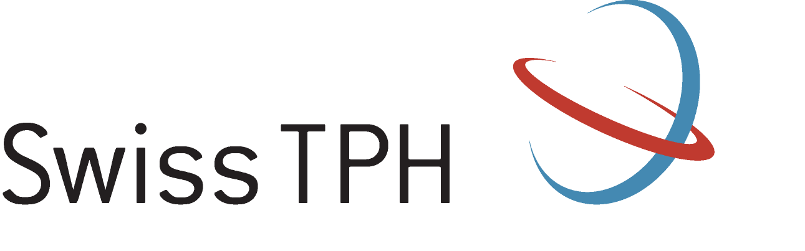

20.02.2017 Kristina Pelikan (Supervision: Jakob Zinsstag)
“Enhancing and analysing project communication - interaction of theory and practice”

27.02.2017 Louisa Warryn and Jean-Pierre Dangy (Supervision: Gerd Pluschke)
“The Mycobacterium ulcerans macrolide toxin mycolactone as target for diagnostics and vaccine development”

06.03.2017 no event (FASNACHT)

13.03.2017 Claudia Schmutz (Supervision: Daniel Mäusezahl)
“Foodborne infections - neglected diseases in Switzerland?!“

20.03.2017 Fayiz Abakar (Supervision: Jakob Zinsstag)
“Towards integrated health syndromic surveillance and response in Africa”

27.03.2017 Ali Ali (Supervision: Tom Smith and Melissa Penny)
“Population Pharmacokinetic Modelling and Simulation of Anti-Malaria drugs to optimize dosing in neglected populations”

03.04.2017 Mélanie Pellison (Supervision: Matthias Rottmann)
“Targeting the hypnozoites: Towards an in vitro system for antimalarial drug discovery“

10.04.2017 Bolor Bold (Supervision: Jakob Zinsstag)
“Estimating the burden, cost of disease and optimization of the clinical algorithm of human cystic echinococcosis in Mongolia”

24.04.2017 Sabine Renggli (Supervision: Christian Lengeler)
“Towards improved health service quality in Tanzania: An approach to strengthen supportive supervision”

08.05.2017 Joanna Gallay (Supvervision: Blaise Genton)
“Antimalarial drug concentrations in blood as a monitoring tool for evaluating population drug usage and appropriateness of health professionals care”

15.05.2017 Laura Ruckstuhl (Supervision: Christian Lengeler)
“Malaria control in Central Africa”

22.05.2017 Natalie Wiedemar (Supervision: Pascal Mäser)
“Transcriptomics of suramin resistance in Trypanosoma brucei”

29.05.2017 Sanjay Sagar (Supervision: Martin Röösli)
“Monitoring of non-ionizing radiation exposure levels in different microenvironments in an international context”

